Problem Statement

1.b]

STEP] Downloading the pdf files from the given link and importing them in a new folder named “DCCASSIGNMENT_23110076”

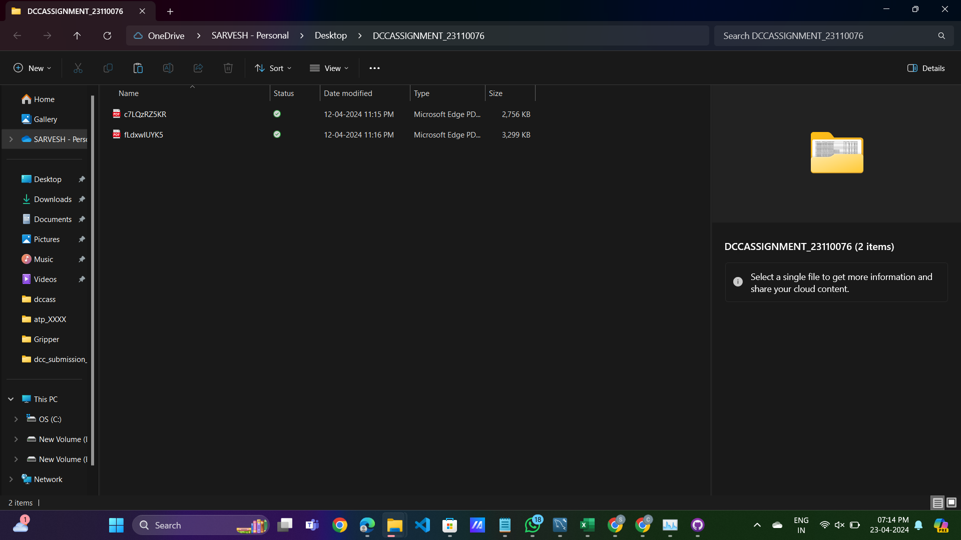

STEP] Open The folder in the VS Code to convert the PDF files to csv.

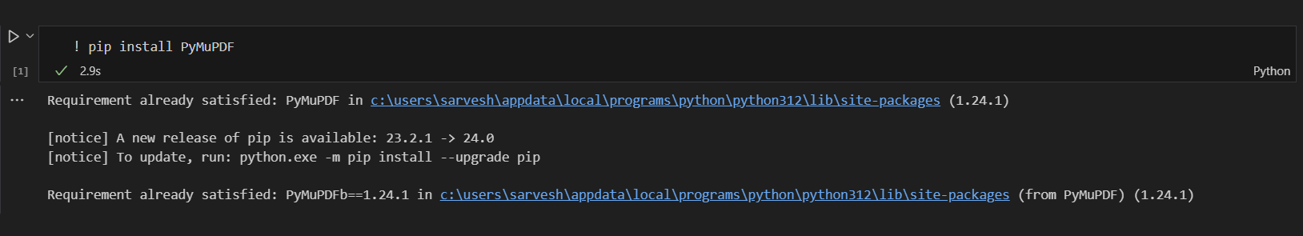

Installing PyMuPDF module in VS code which will be used to convert PDF files to csv.

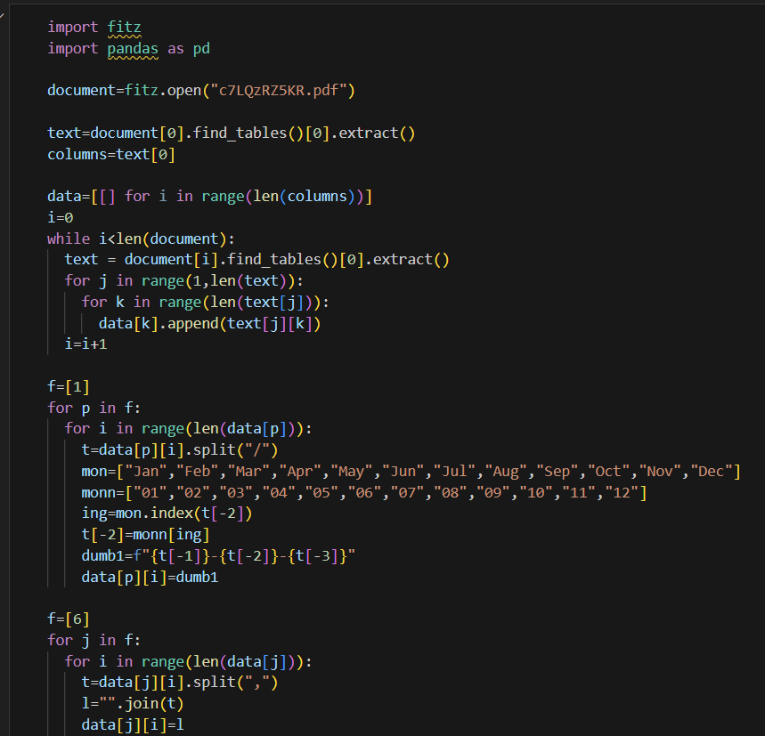

Reading PDF files using the method “fitz.open()”. Iteration of tabular data of each page and getting access to which row of the table. Processing data such as changing the format of date from dd-mon-year to dd-mm-yyyy and changing the presentation of values in denomination ex. From 10,00,000 to 100000.

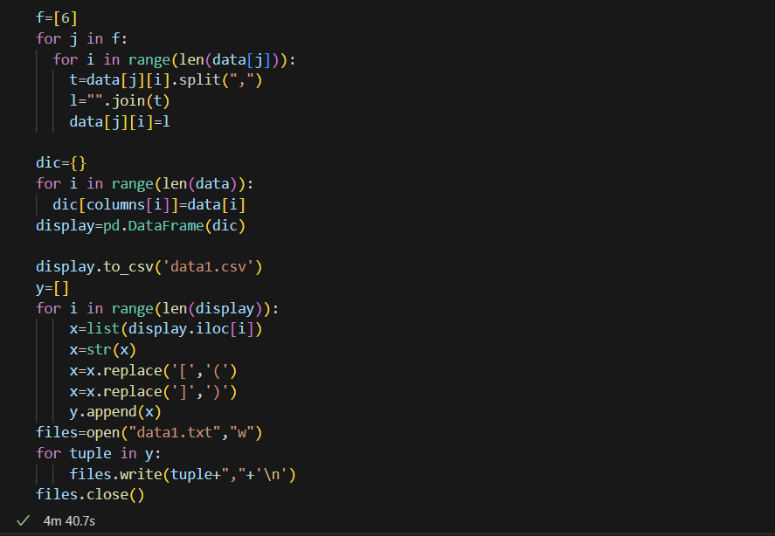

After processing data, creating a list for each column and then creating a dic and eventually creating a DataFrame with the help of pandas library. Creating a csv of given pdf files using the method pd.DataFrame.to_csv(“data1.csv”).

Inorder to create a table in database and inserting the data available ,creating a query in text form which becomes easier by simplifying copying entire text file to sql query.

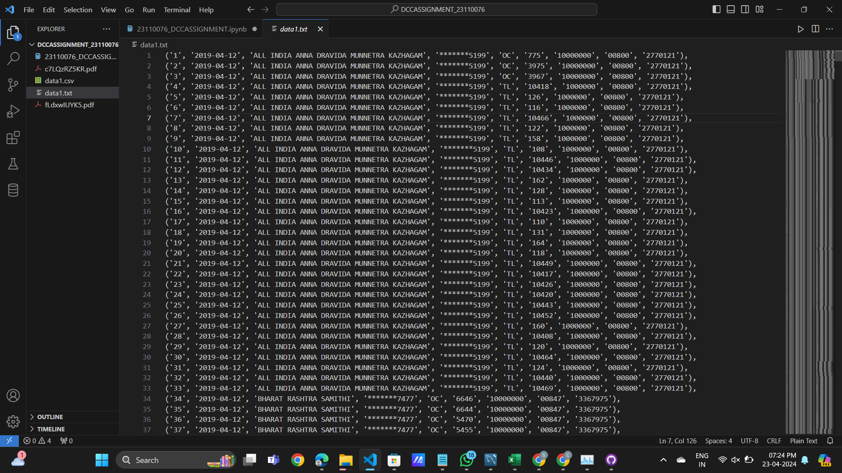

Now,creating a database named “dccassign” and creating tables named as “data1” and “data2”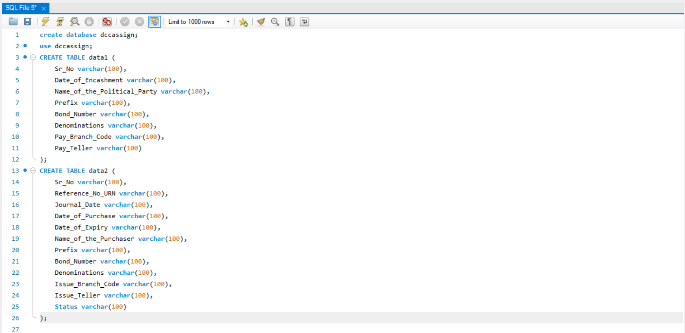

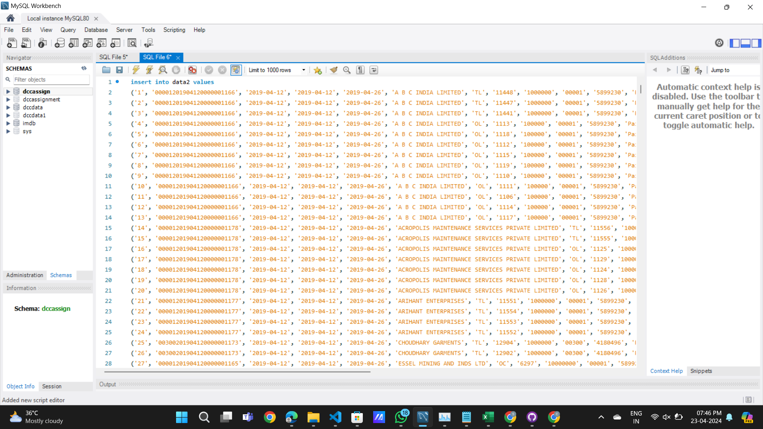

Inserting values in table via copying text from “data1.txt” to query file in mysql workbench.

Now connect by database “dccassign” to flask using the “flask” and “flask_mysqldb” modules.

Creating a flask application instance and specifying the folder in which the Flask should look for the html templates.

Then specifies the hostname ,user,password and database of the MySQL server.

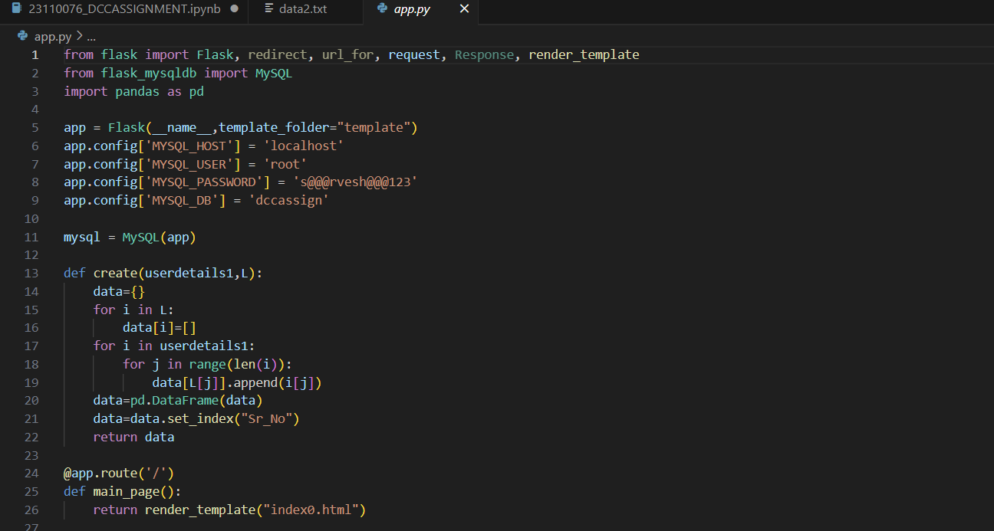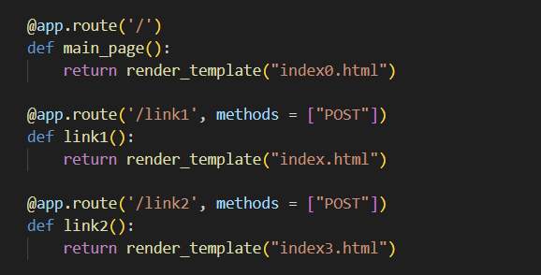

1.e]

User Interface.

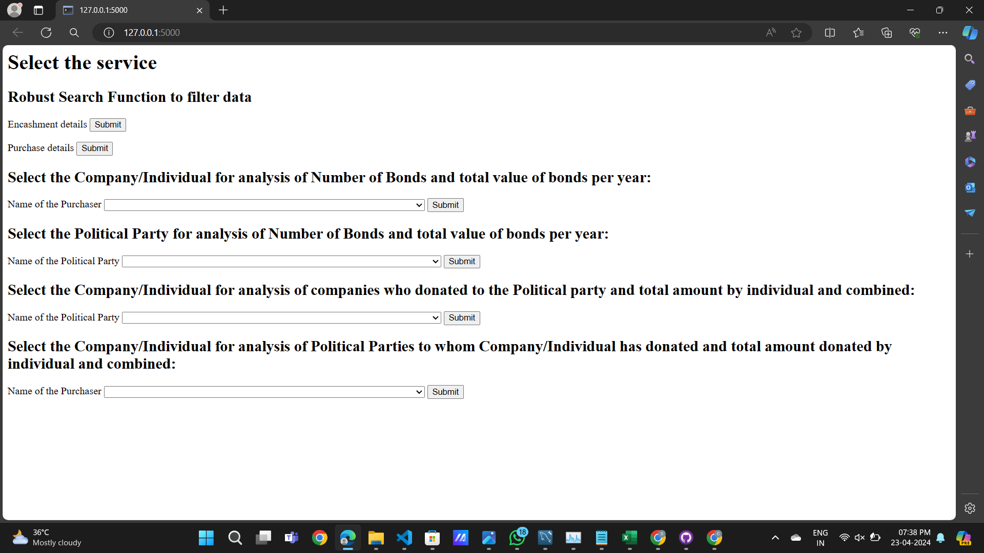

1]Implement robust search functionality that allows users to quickly search for specific records based on Bond Number or filter data based on any column in the table except Sr. No. and Status (e.g., date, political party, company name). The output should be displayed in the form of a table which is fetched from the database for a given query.

Function is used to filter data according to the filter selected from the user interface. Displaying the resultant data in the form of a table using pd.DataFrame.to_html().

1]For analysis of data from the encashment table.

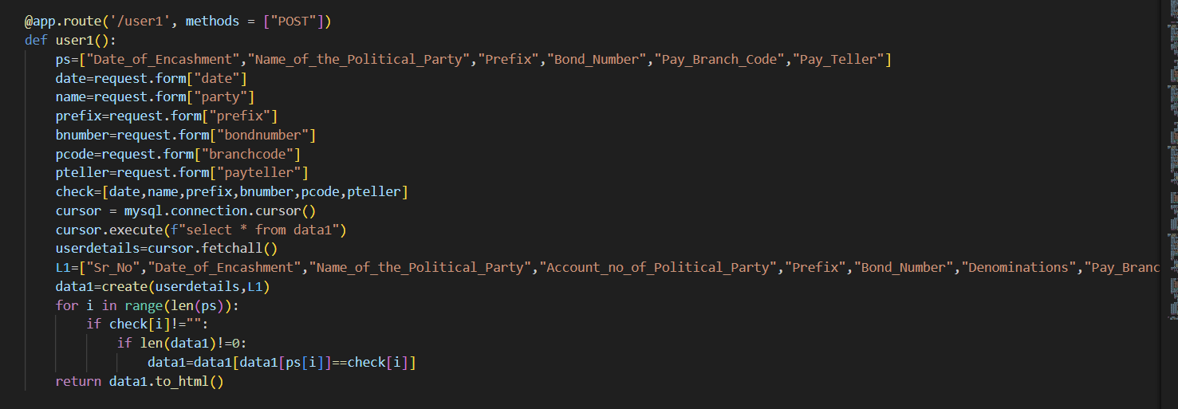

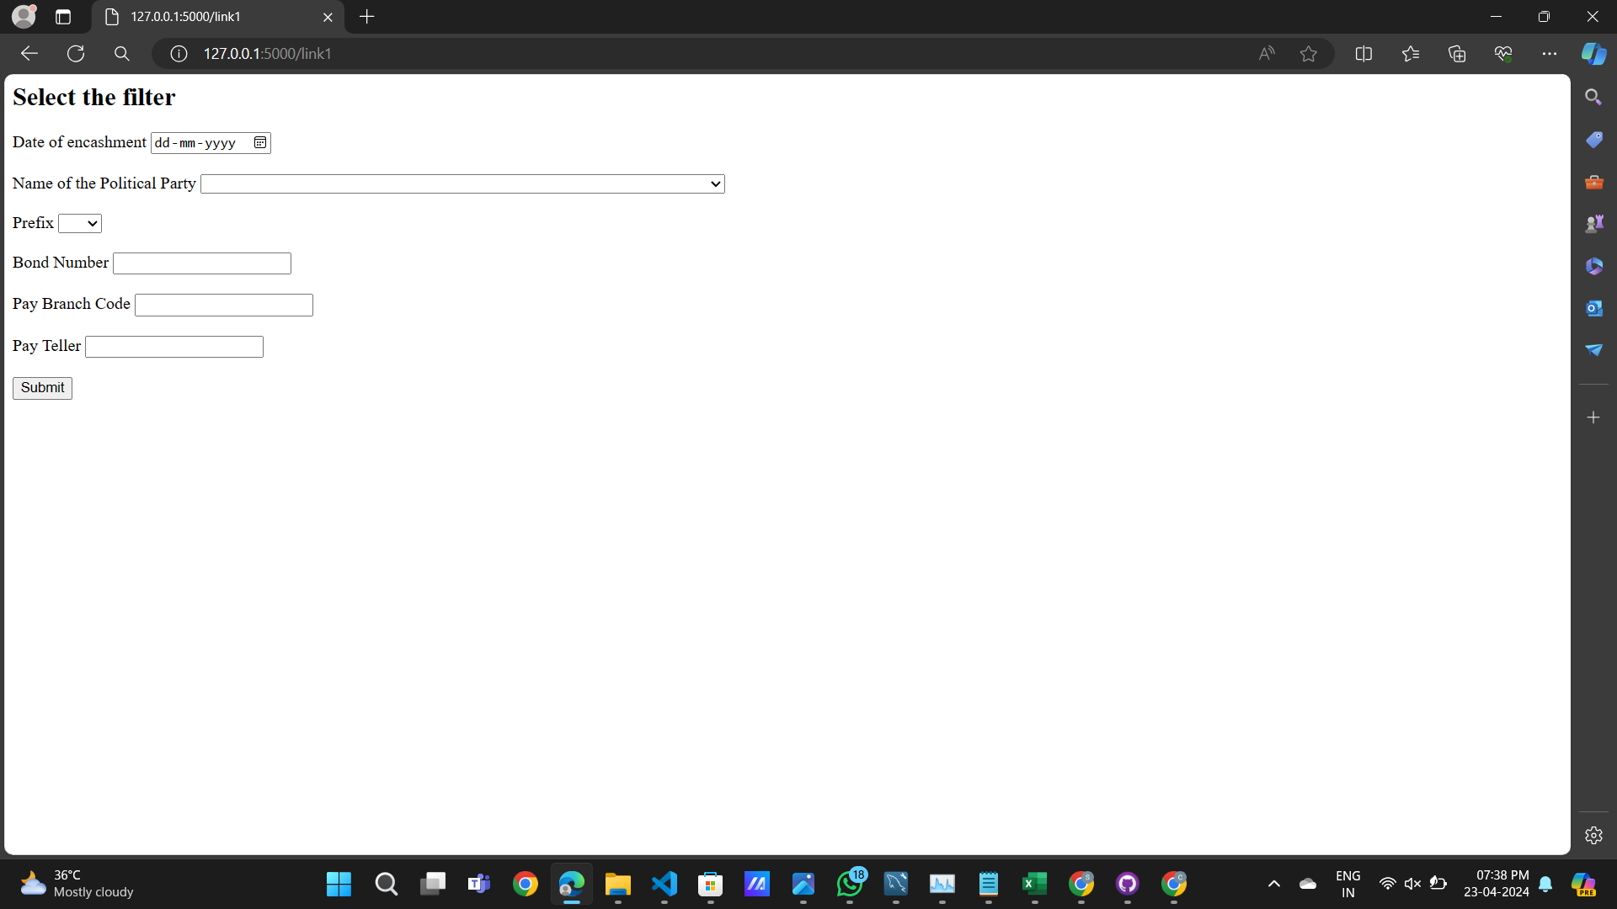

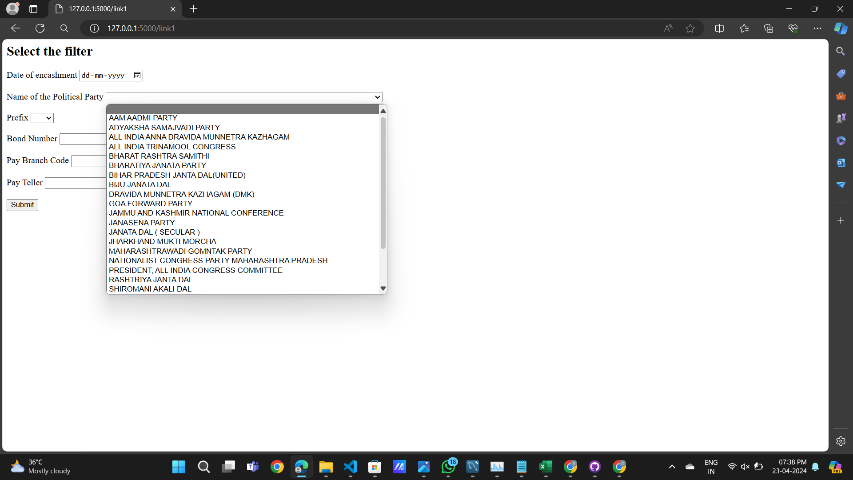

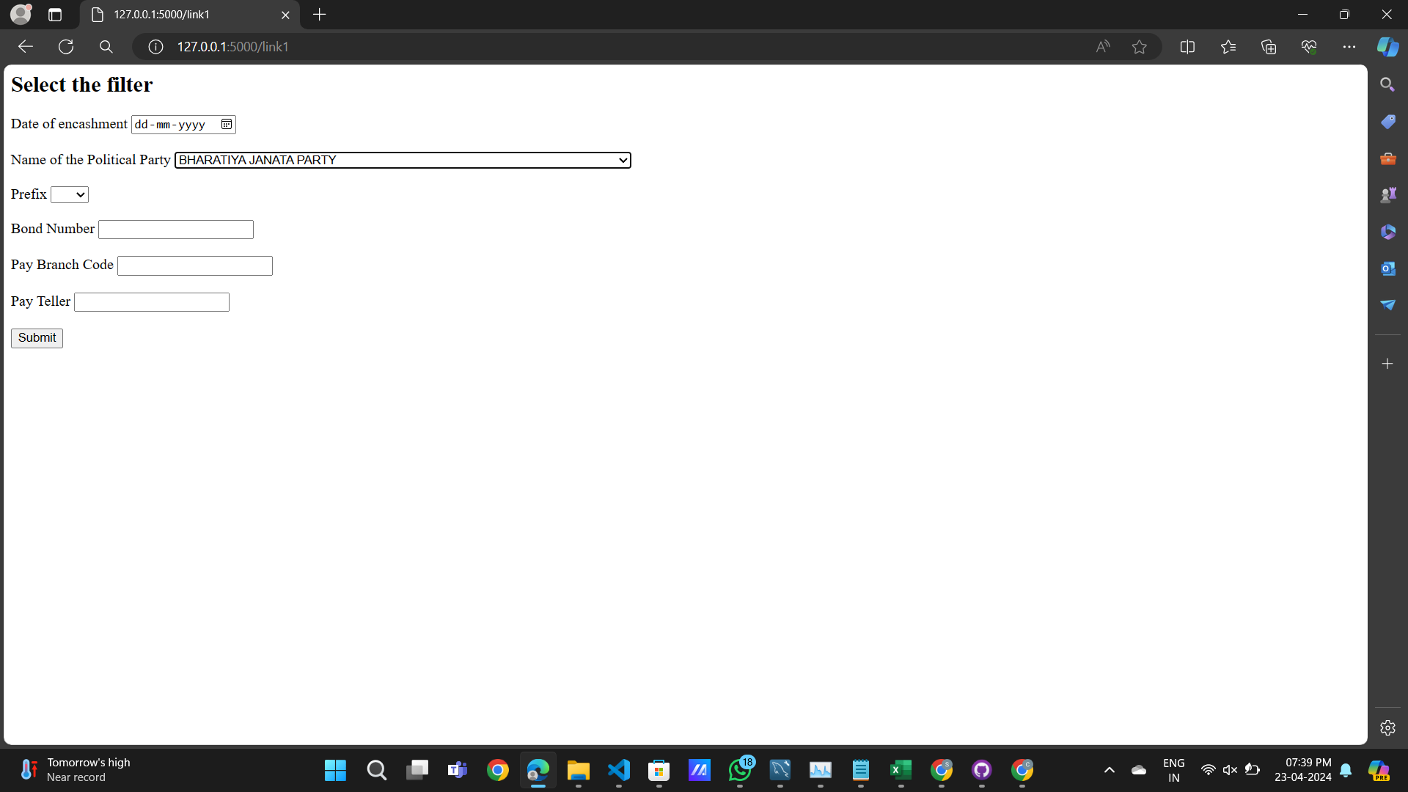

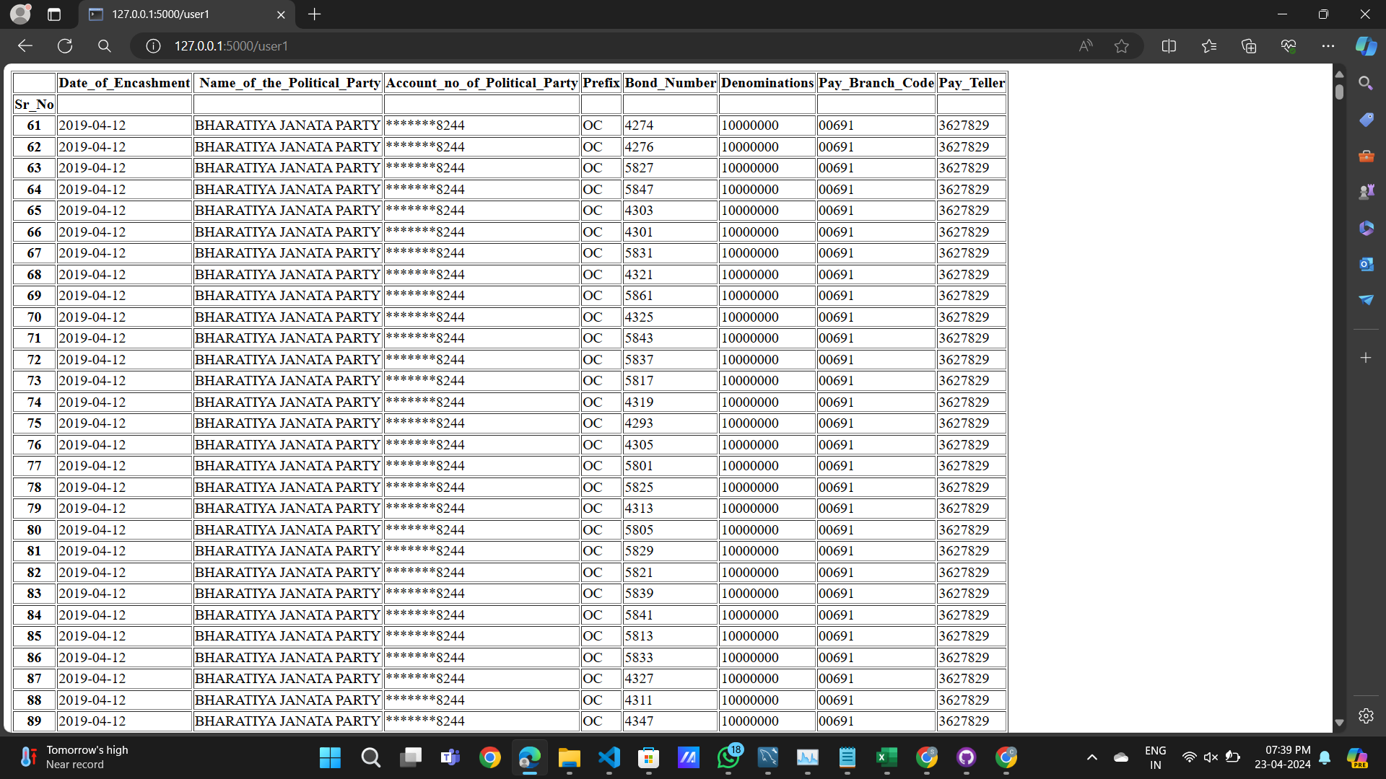

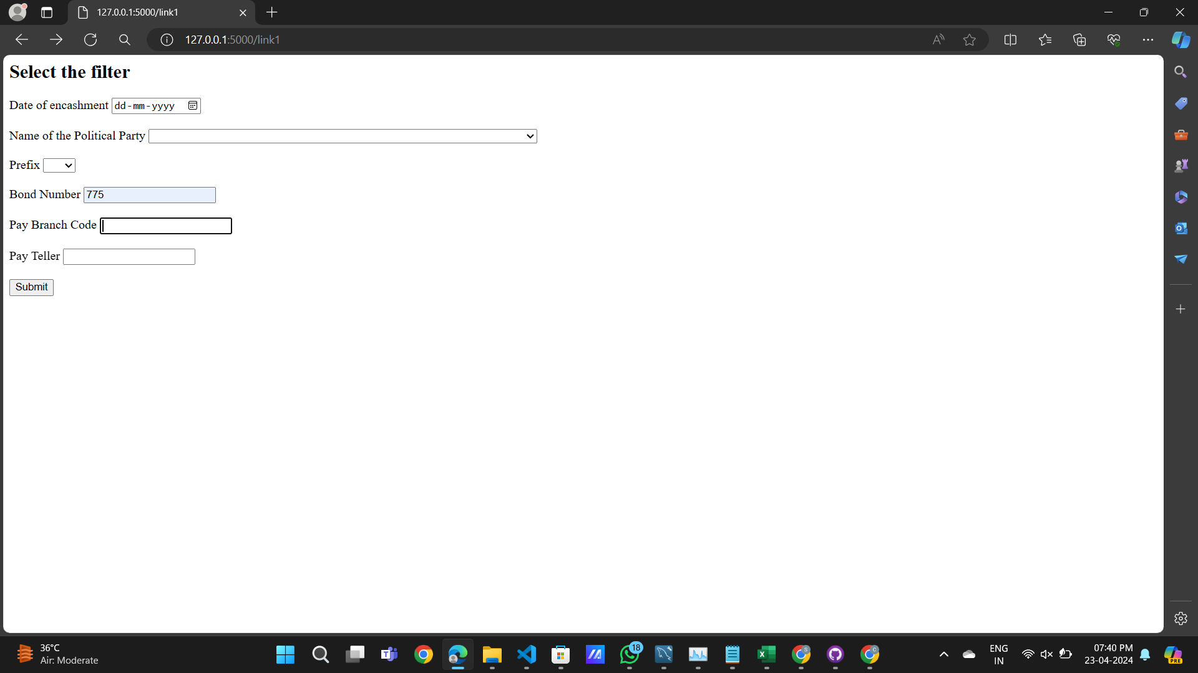

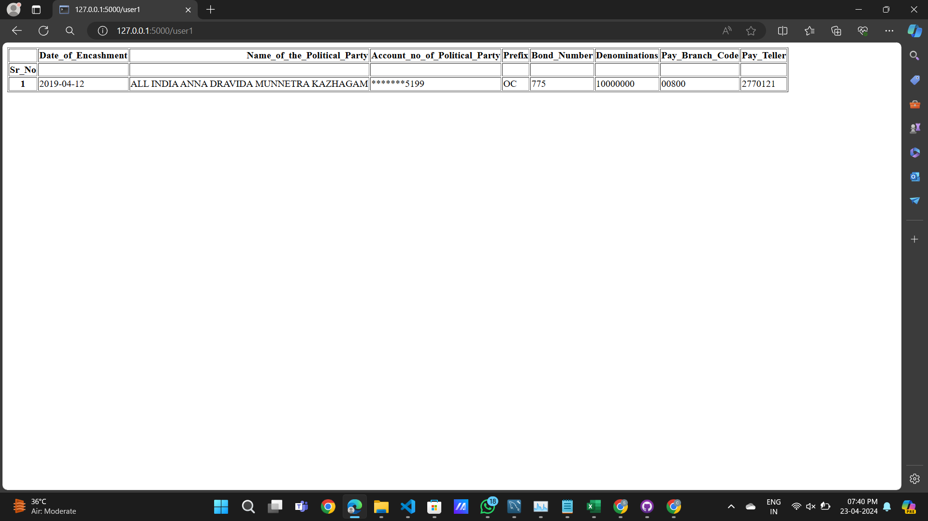

Similarly, for analysis of purchasing table

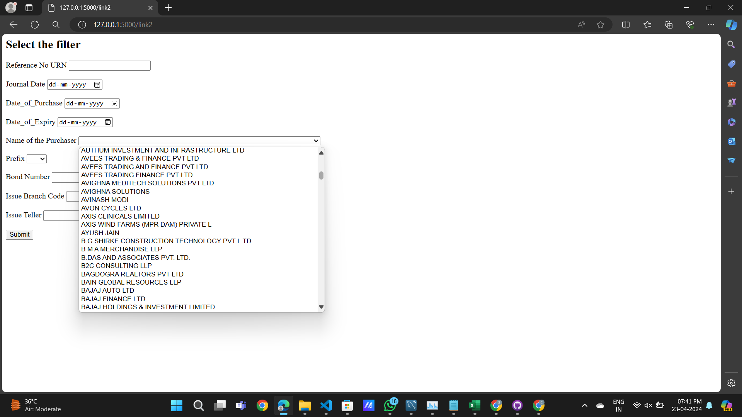

2]The option to select a Company/Individual from a drop-down/search, and show how many bonds and the total value of bonds purchased per year. You can present a bar plot depicting your results.

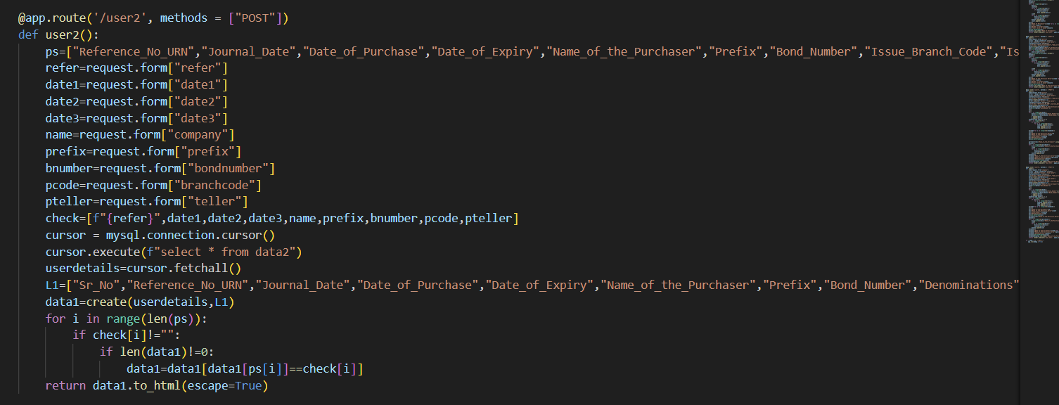

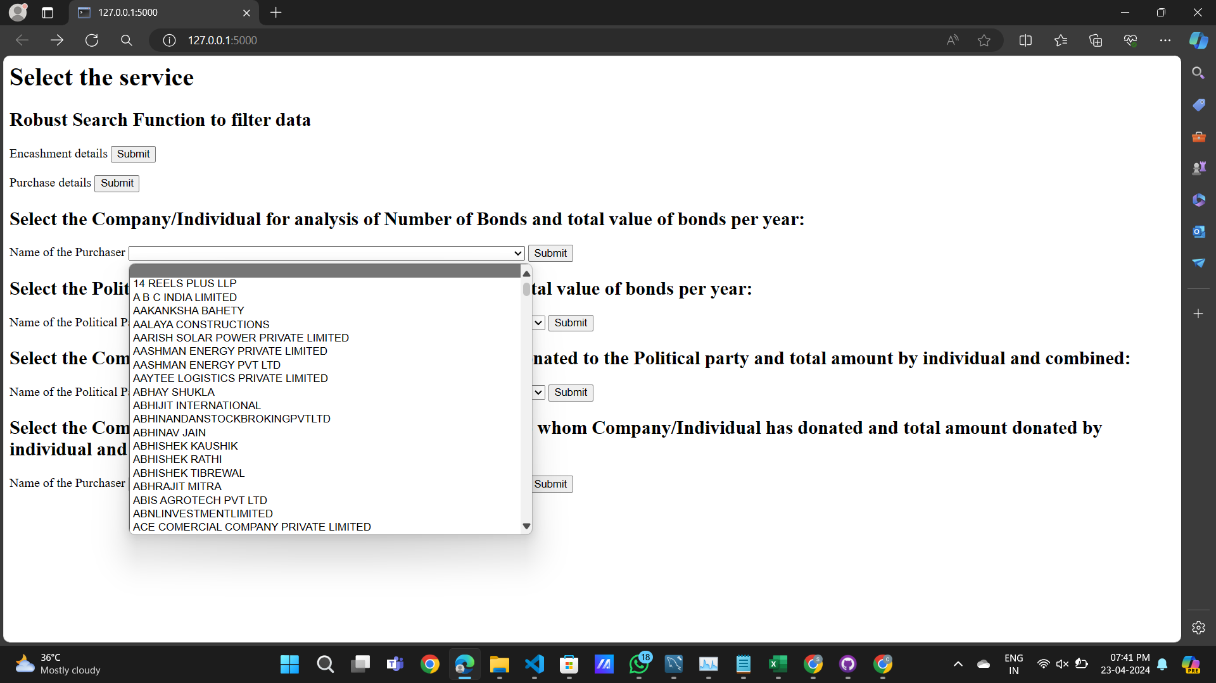

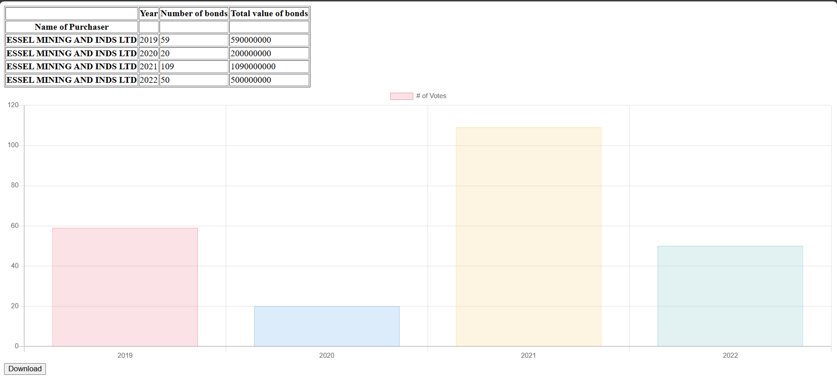

3]The option to select a political party from a drop-down/search, and show how many bonds and total value per year are in the timeline. You can present a bar plot depicting your results.

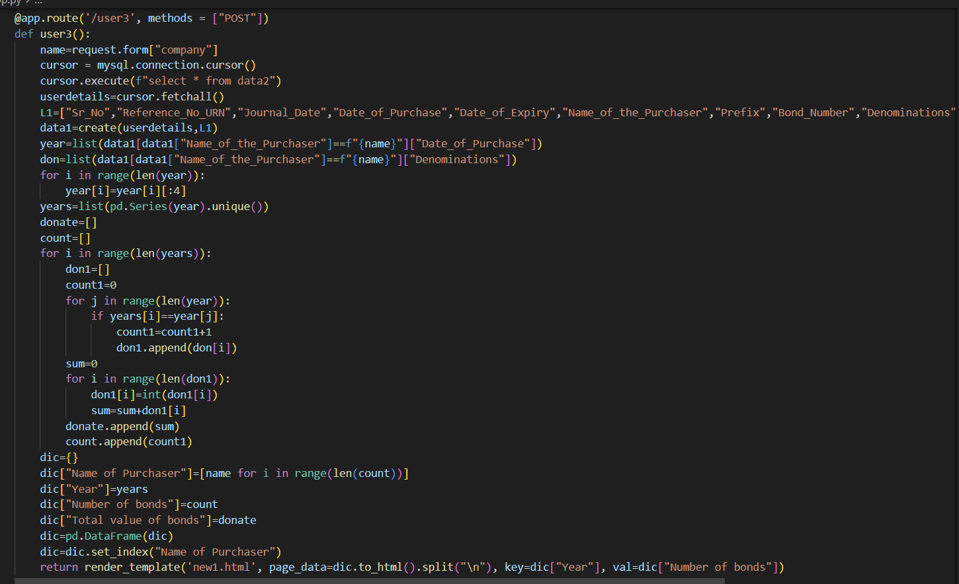

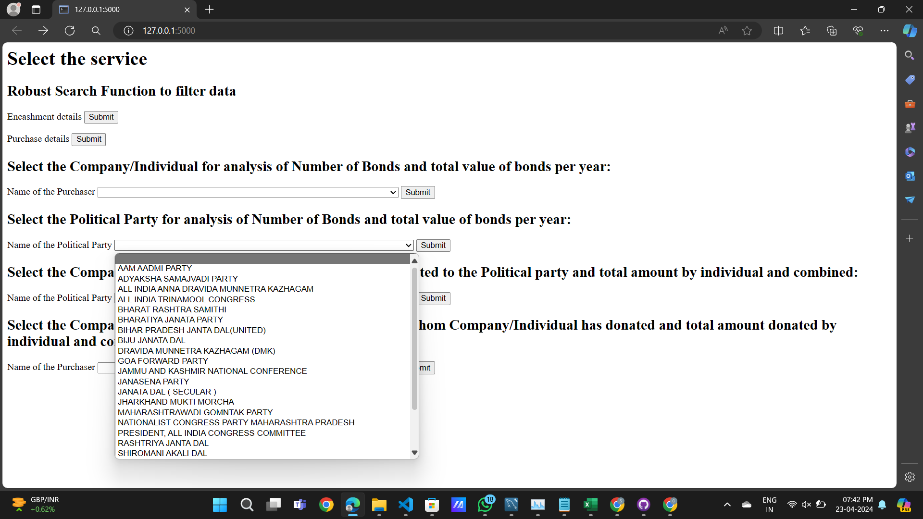

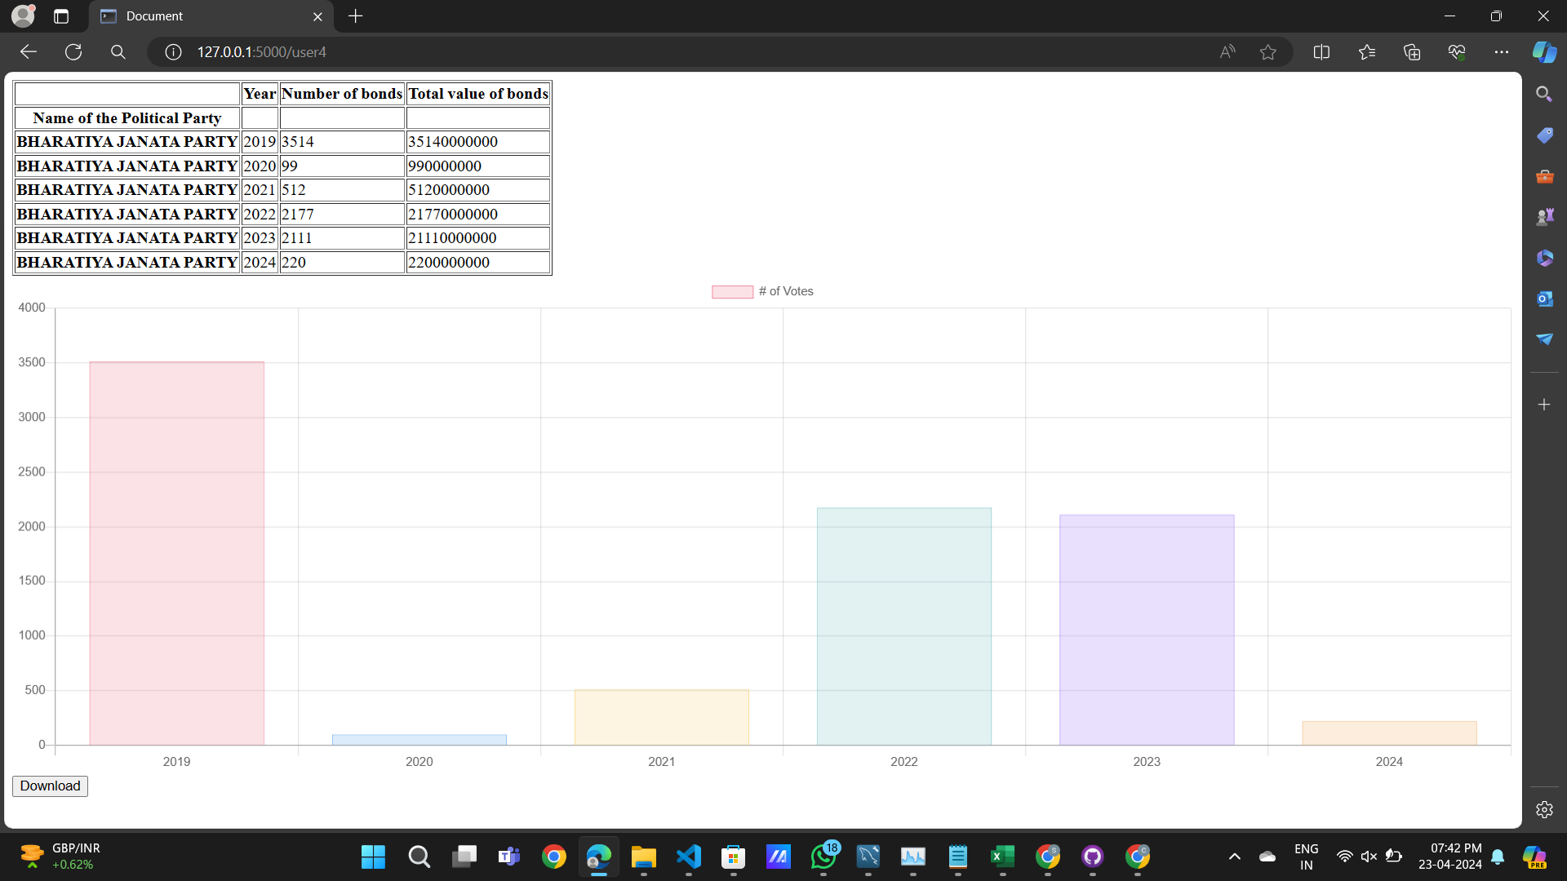

4]The option to select a political party from a drop-down/search, shows which companies have donated to it and what amount individually and combined.

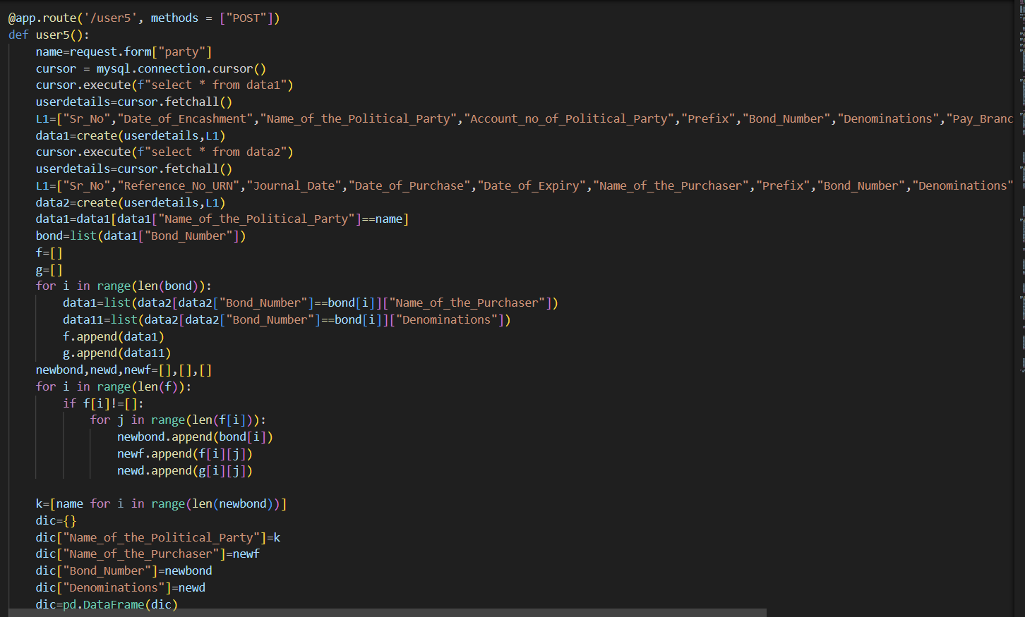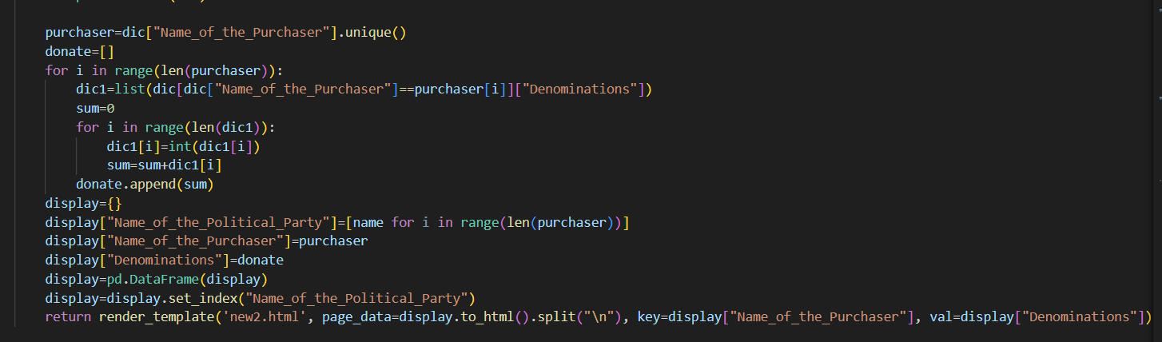

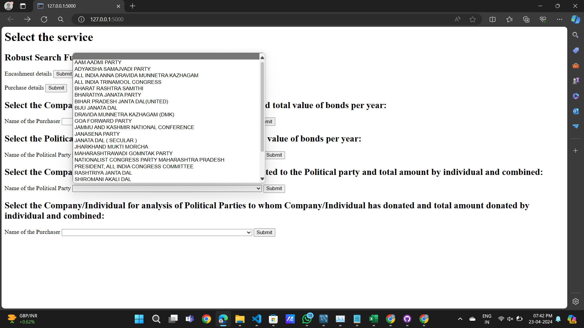

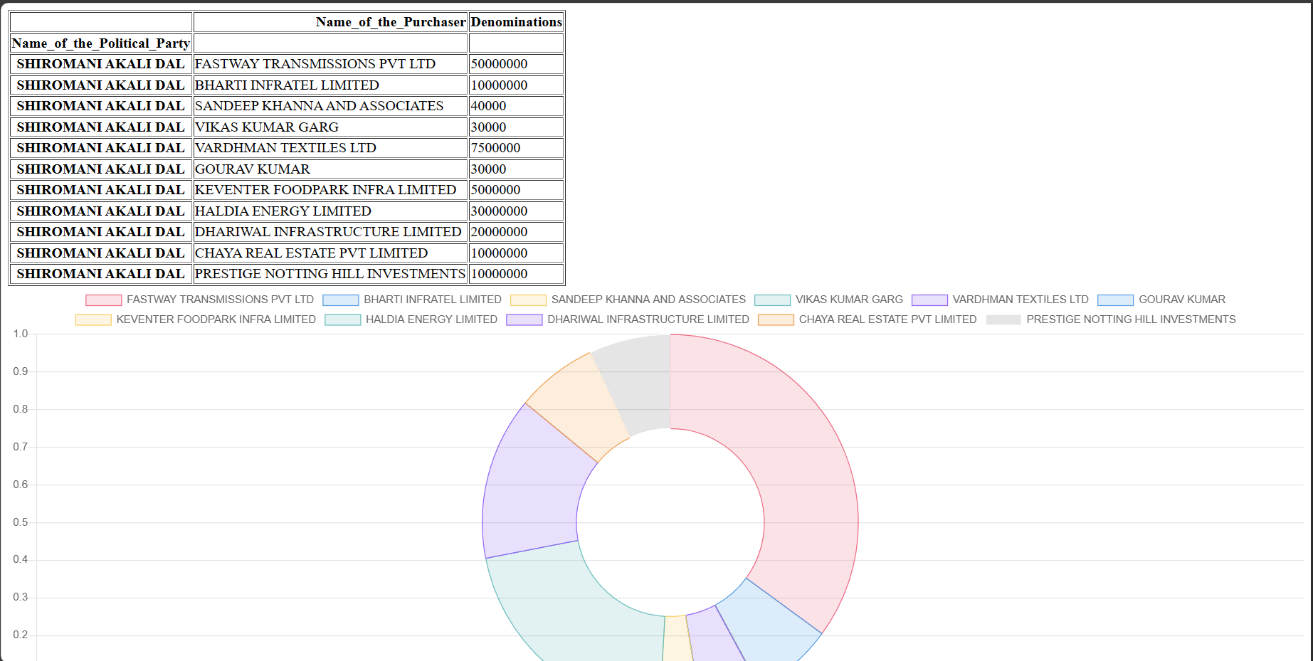

5]Similarly, provide an option to select a company from a drop-down/search, showcasing which parties they have donated and what amount individually and combined.

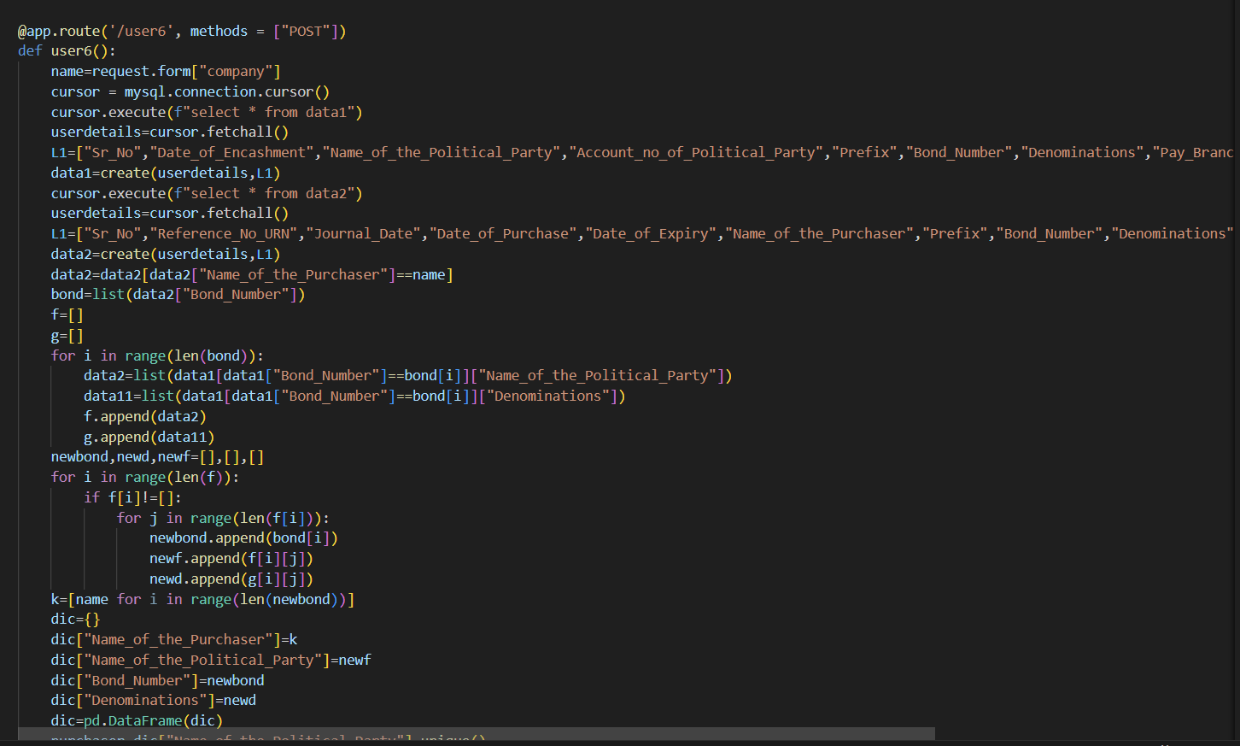

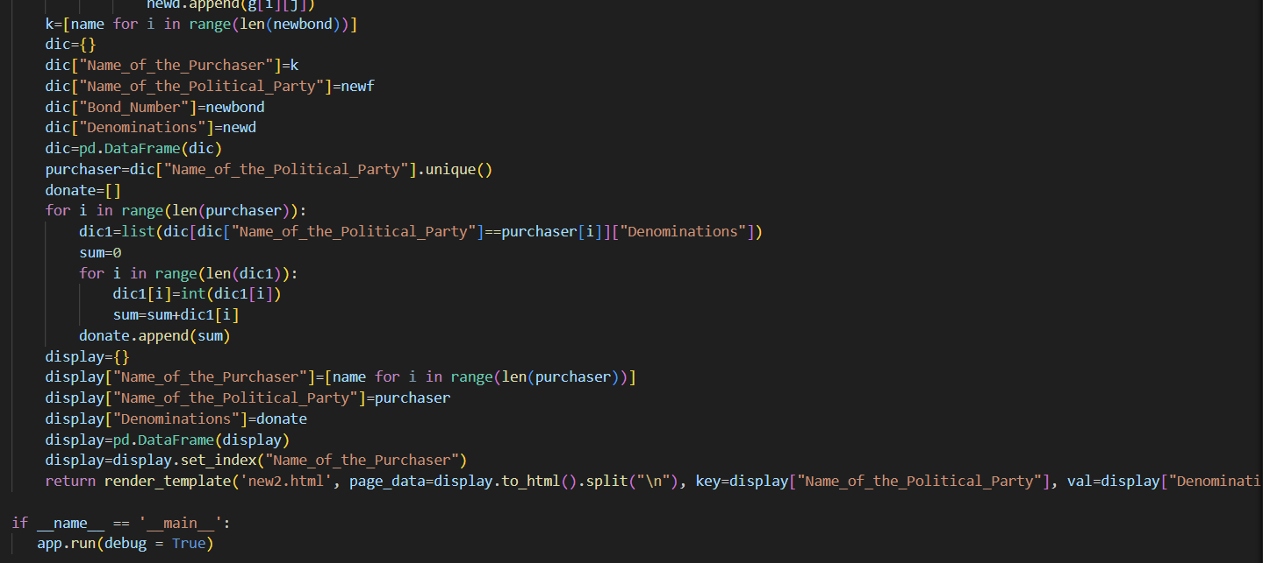

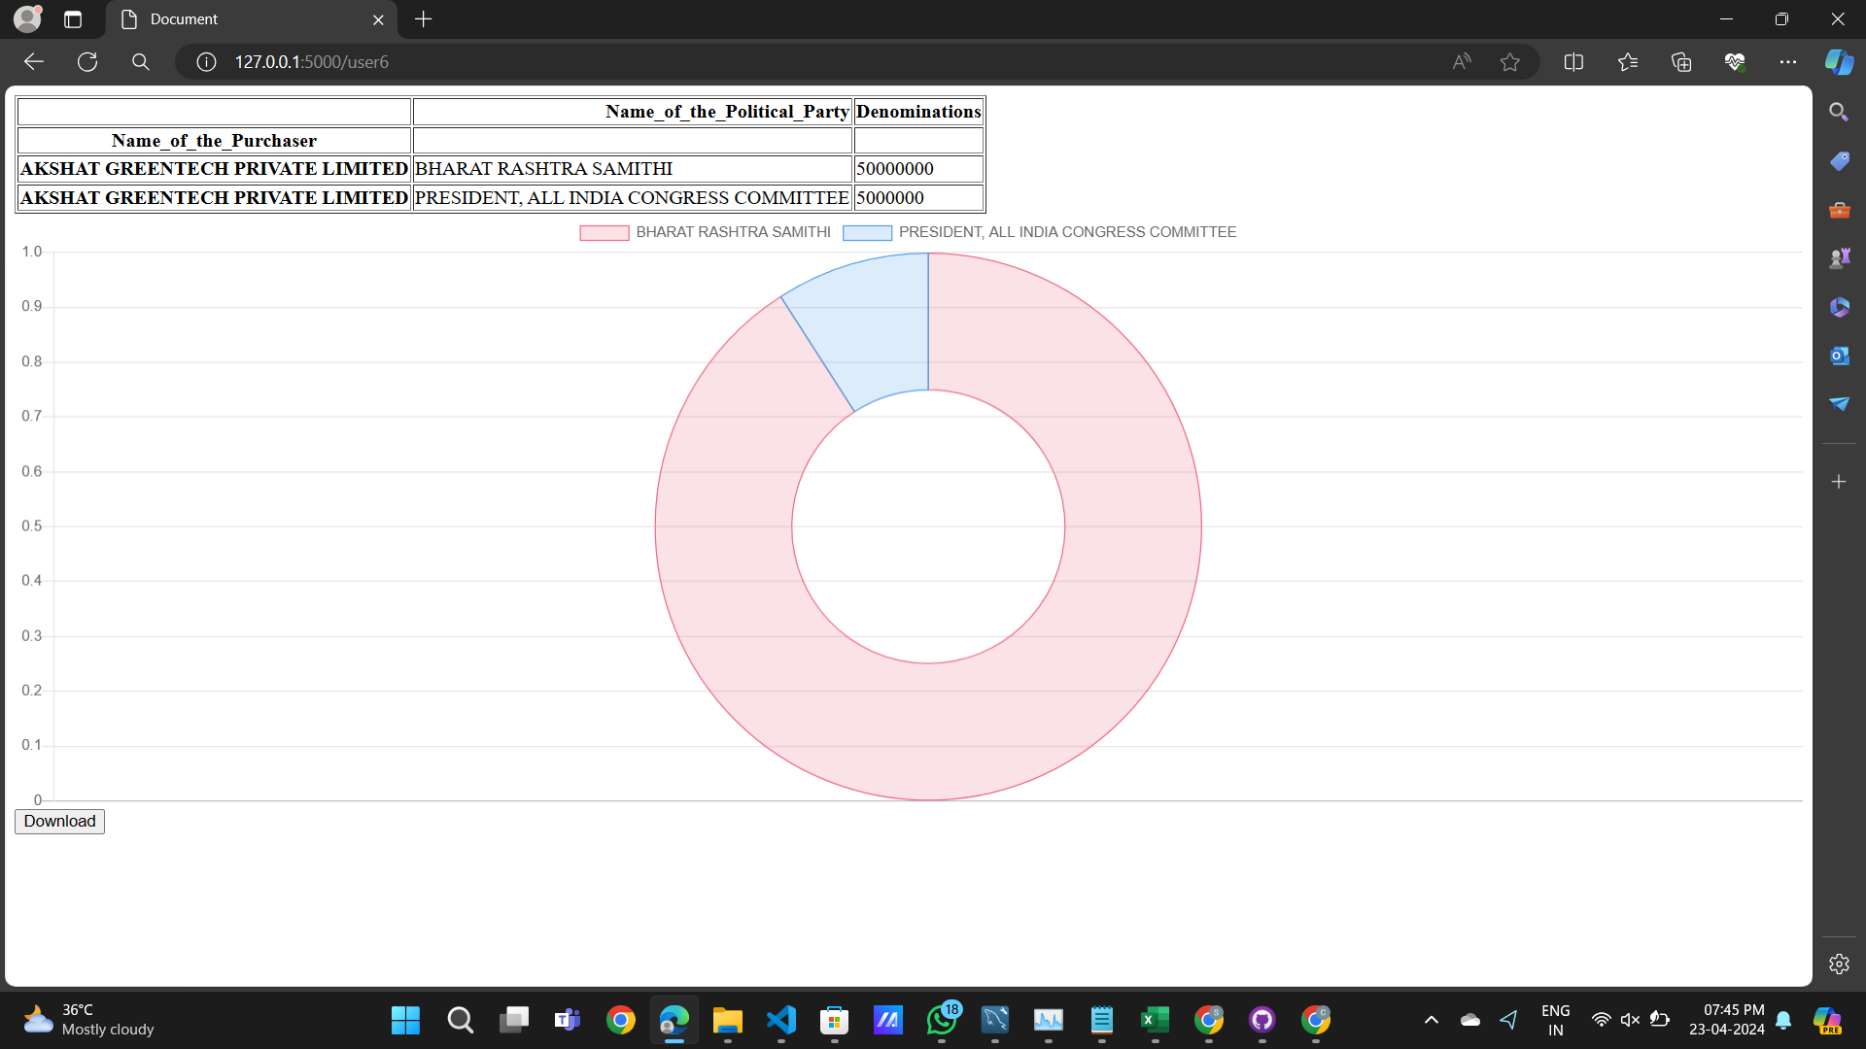

6]Apart from 1e4 and 1e5, you can also display the Pie chart depicting the total amount of donations to all the parties.

